






Child/Family Services Division

Free Child Care Services for Children Ages 0-5

We provide FREE family services that include:

Nutrition  Prenatal | Education  Social | Health  Dental | Disability  Literacy
Information on community-based transportation services is provided
upon request; for example, public transportation routes.

Central California Migrant Head Start

Regional Head Start

Early Head Start

Now Accepting Applications!

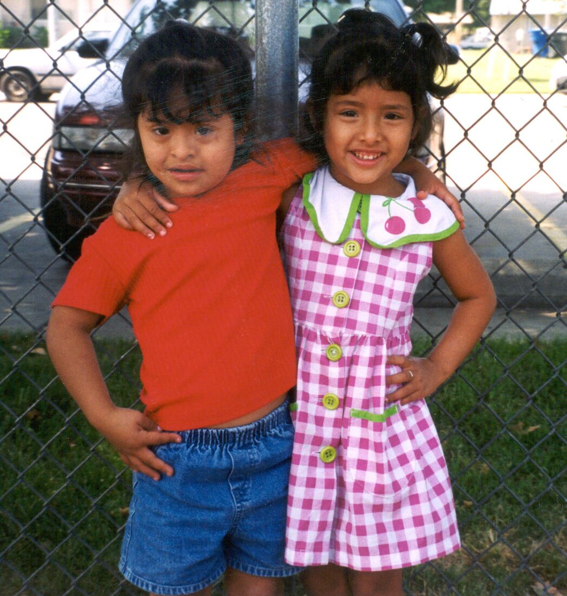
Who Qualifies:
- Priority given to children with disabilities
- Children ages six (6) weeks to five (5) years of age
- Migrant/seasonal farm workers
- Pregnant women
- Teen parents are encouraged to apply

Contact Child/Family Services for more information

(209) 525-4937 (209) 558-4030

1100 H Street 1324 Celeste Drive
Modesto, CA 95354 Modesto, CA 95355

