
Early Head Start Program
Now Accepting Applications!

Free Child Care Services for Children Ages 0-3

We provide FREE family services that include:

Nutrition  Prenatal | Education  Social | Health  Dental | Disability  Literacy

Information on community-based transportation services is provided
upon request; for example, public transportation routes.

Who Qualifies:
- Priority given to children with disabilities
- Children ages six (6) weeks to thirty-six (36) months of age
- Low income eligible families
- Pregnant women are encouraged to apply
- Teen parents are encouraged to apply
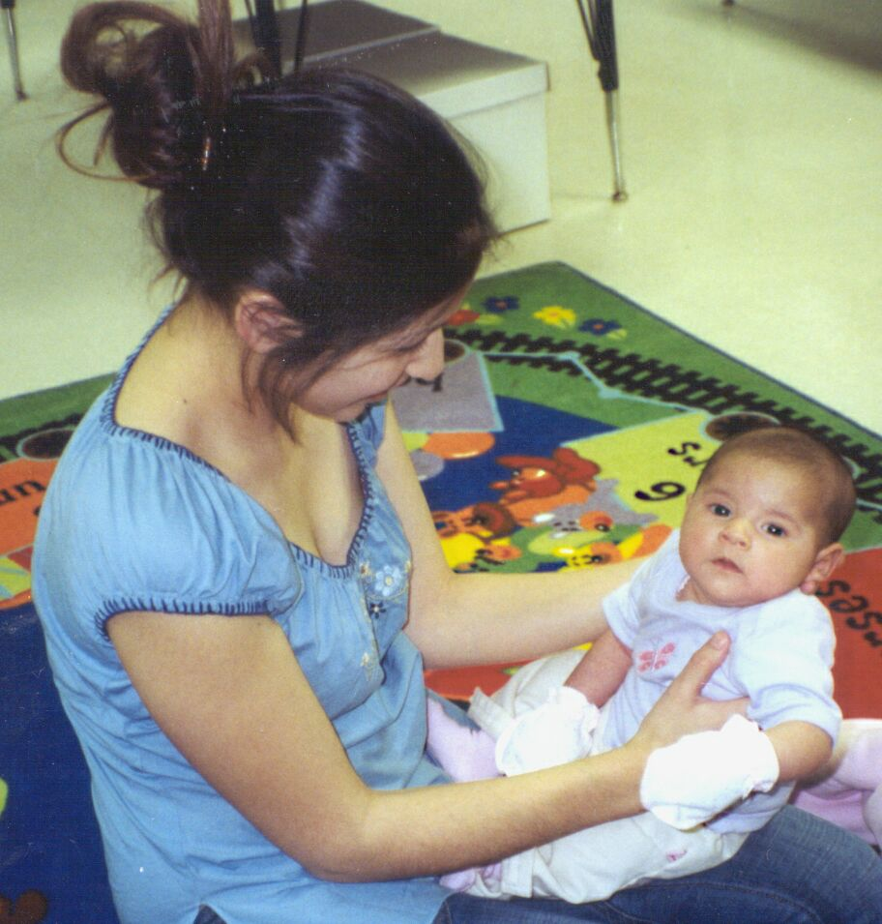
What You Need To Have:
    - Family income verification
    - Child’s birth documentation
    - Child’s immunization record

Available Program Options:
 Center Based  Family Child Care Home
 Pregnant Women  Home Based

For more information or to schedule
an appointment to apply, contact:

(209) 525-4937 (209) 558-4030

1100 H Street 1324 Celeste Drive

Modesto, CA 95354 Modesto, CA 95355

